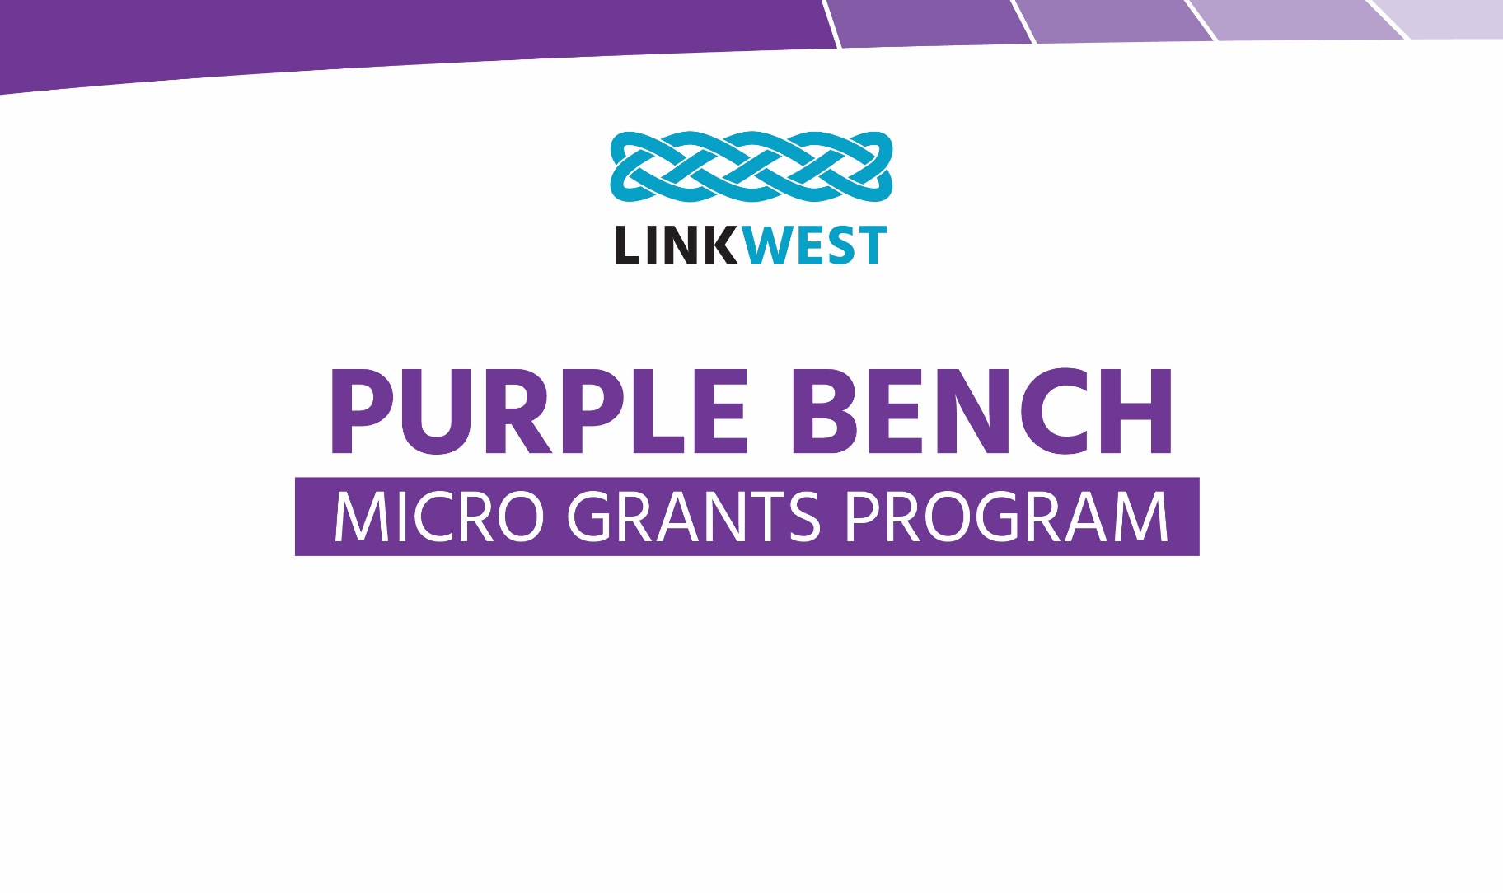

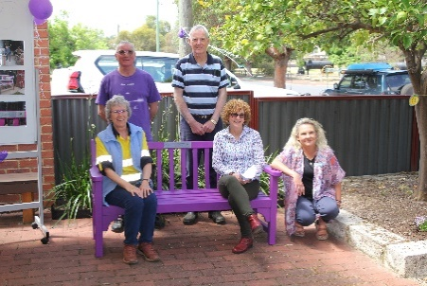
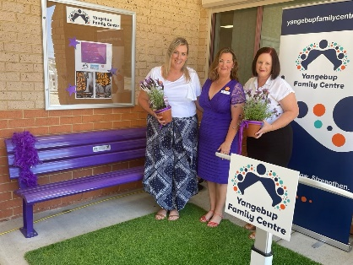
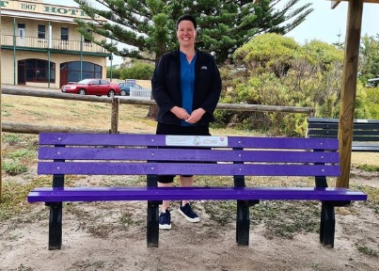

Helping our members provide permanent reminders
that their Centres are safe and confidential spaces
for women to visit with their children.

16 micro grants of $300+GST to assist members to sponsor a Purple Bench at their Centre.
In the 2023 – 2024 financial year, Linkwest is once again offering purple bench micro grants. We are delighted to continue to offer grants of $300+GST and the grant money is possible thanks to the generosity of:
- Loftus Community Centre (Loftus was a member of Linkwest for 40 years and sadly closed leaving the remaining money to Linkwest for this grant program)
- EEO Equal Opportunity Specialists
- Linkwest
Linkwest member Centres can use these micro grants to assist with the cost of materials to transform an existing bench, or to subsidise the cost of purchasing a new bench. Grants will be awarded on a first-come, first-served basis.
In part due to Linkwest's five previous micro grant rounds, our network of Centres is part of a growing footprint of Purple Benches across Western Australia, which honour the memory of women murdered by their partners and provide help numbers for people experiencing Domestic Violence.
Applications for Purple Bench Micro Grants are now open for this financial year.
This round closes: Friday, 7 June 2024 OR as soon as 16 valid applications are received.
Monies will be deposited into the Centre’s bank account within a fortnight of receiving advice your application has been successful.
Linkwest Purple Bench
Micro Grant Application Form
Eligibility
Only current CRC Package and Neighbourhood Centre members of Linkwest who have not previously been awarded a Purple Bench Micro Grant are eligible to apply.*
* If you have already received a grant but you have reason to replace – or repair – a previously installed bench (i.e. safety reasons), please contact Linkwest. You may be eligible to apply for another grant to help with the replacement/repair costs.
Contact Details
Member Centre Name
Address
Suburb |  |  |  | Postcode
Person responsible for this application
Position
Phone (W) |  |  |  | Mobile
Email
Are you registered for GST? |  |  | No | Yes
ABN
Organisation’s bank details: where the grant funds will be deposited
Please ensure you provide accurate details to avoid delays and associated (bank) charges for misdirected funds
Account Name
BSB |  |  | A/C No

Grant Application Authorisation
I have the authority to act on behalf of the member Centre applying for a Linkwest Purple Bench Micro Grant.
I confirm that the member Centre I represent fulfils the eligibility requirements.
If our member Centre’s application is successful, we undertake to:
- Register interest with the Centre for Women’s Safety and Wellbeing (CWSW) to sponsor a Purple Bench, using the CWSW Purple Bench registration form.
- Follow the guidelines (checklist of things to consider) in the CWSW Purple Bench registration form (link as above).
- Include a plaque on our bench (mandatory inclusion) – see here for a plaque example.
Specifications are as follows:
  - Material: preferably stainless steel.
  - Suggested Dimensions: Width: 190 mm Length: 55 mm
Note: You may need to adjust to suit your logo / name requirements
  - Wording to be included: In honour of all victims of domestic homicide.
For advice and support, phone the Women’s DV helpline on 1800 007 339
  - CWSW logo – vector version as supplied by Linkwest
  - Centre logo OR Centre name (in text)
  - The plaque is (ideally) to be located on the front of the bench, centred on the top slat. If this is not possible, then on a prominent part of the bench
- Have a purple bench installed outside - or in close proximity to - our Centre by
Saturday, 30 August 2024.
- To acknowledge Linkwest, the Loftus Community Centre, EEO Equal Opportunity Specialists and Dulux in any promotions (including social media), inauguration ceremonies etc., of your Purple Bench.
- 16 Days in WA (25 November to 10 December) – you commit to raising awareness of the annual Stop Violence Against Women campaign by using your Centre’s Purple Bench as part of your campaign to educate, motivate and advocate in your community to stand up to stop violence against women.
- Lodge a grant acquittal to Linkwest by: Monday, 30 September 2024.
For this acquittal, we will provide:
- At least one good quality photo, with a caption of our bench in-situ.
- Receipts (up to the value of $300+GST) for the cost of materials to transform an existing bench, or to subsidise the cost of purchasing a new bench.
- A brief explanation of why our Centre has chosen to sponsor a purple bench.
Note: Linkwest will issue an invoice for return of the Micro Grant to Centres who do not acquit by the deadline.
Member Centre:
Contact person:
Position:
Signed: |  | Date:
(Double-click on the image box above to insert your signature as an image)
Please submit your application for the Linkwest Purple Bench Micro Grants by:
Friday, 7 June 2024
Email to: office@linkwest.asn.au

Please feel free to phone the Linkwest office should you have any questions: 08 6164 9823
Checklist of Deadlines
Closing date for applications Friday, 7 June 2024
Have your purple bench installed Saturday, 31 August 2024
Acquit your micro grant Monday, 30 September 2024

